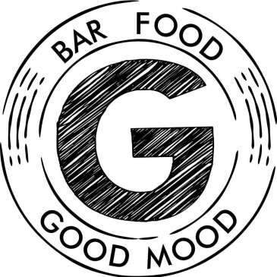
Gambas Sunday Menu
Starters
Grilled Halloumi and Spanish Chorizo £8.50
Cajun Spiced Chicken Wings Served With Sour Cream £8

Hummus and Taramasalata served with warm pitta bread £7.5

Salt and Pepper Squid with garlic Mayo £8.50

Garlic Chilli coriander Tiger Prawns served with Rustic Bread £9.95

Mains

Traditional Roast - Choose from Mint lamb, Honey-glazed gammon and Topside of beef or Nut Roast £15

Chicken Carbonara Served with button mushrooms, bacon lardons, spring onions and spinach £19
Calves liver crushed new potatoes, bacon and onion gravy £18

Cheese and Bacon Beef Burger served with Mayo, hand cut chips, Slaw, Onions Ring, Baby gem lettuce, tomatoes, red onion £20.50

Prawn Linguini Served with white sauce, spinach, parmesan and Tiger prawn £20

ALL DESSERTS OVER PAGE
Desserts

Lemon Posset served with homemade shortbread £8

Salted Caramel, Chocolate or Raspberry Brownie Sundae £8

Warm Brownie chocolate served with vanilla ice cream £8

Eton Mess with summer fruits and vanilla ice cream and whipped cream £8

Belgium Waffle served with vanilla ice cream, Salted caramel and whipped cream £8

